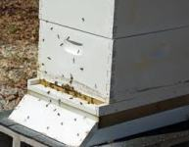 | 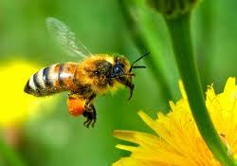 | 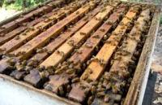
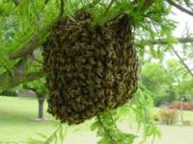 | 9th Annual  North  Alabama  Beekeepers  Symposium  August 17,  2019  Presented By:  Limestone County  Beekeepers Association  WWW.LCBEES.COM  LCBEES.AL@gmail.com | 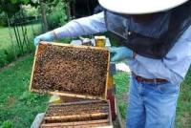
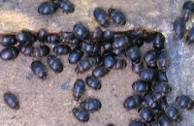 |  | 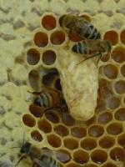
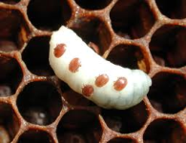 | 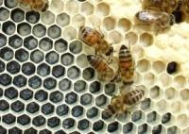 | 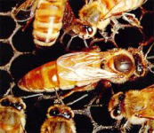
Symposium site:
Friendship United Methodist Church
16479 Lucas Ferry Rd
Athens, AL. 35611
.

Program

8:00 - 8:30 | Registration and Refreshments
8:30 - 8:45 | Welcome - Mr. Lionel Evans
8:45-9:15 | Dr. Clarence Collison - Key Factors in taking Advantage of Nectar & Honey Flow
9:15-9:25 | Break
9:25-10:25 | Session 1
Room | Speaker | Subject
A | Mr. Jack Rowe | Bee a Good Neighbor
B | Mr. Randy Hamann | Monitoring Africanized Honey Bee Activity
C | Mr. Phillip Garrison | Getting into Beekeeping: For Beginners
D | Mr. Bill Mullins | Marketing Your Hive Products
E | Mr. John Mynard | European Foulbrood
10:25-10:40 | Break
10:40-11:40 | Session 2
A | Dr. Geoff Williams | Bees and Best Management Practices
B | Mr. Randy Hamann | American Foulbrood, Varroa, SHB
C | Mr. Bob Fanning & Glen Craiger | Beginning Beekeeping: 1st Year Progressive 1
D | Mr. Wil Montgomery | Queen Rearing—Cell Punch Method
E | Mr. Wes Caudle | Beekeepers---VARROA Public Enemy #1
F | Mr. Todd Mullins | When, Why and How to Feed Bees
11:40-1:00 | Lunch and Door Prizes
1:00 – 2:00 | Session 3
A | Dr. Clarence Collison | The Impact of the Varroa Mite / Virus Complex
B | Mrs. Allyson Shabel | Honey Bee Forage Plants
C | Mr. Bob Fanning & Glen Craiger | Beginning Beekeeping: 1st Year Progressive 2
D | Mr. Bill Mullins | Queen Rearing - Jenter System
E | Mr. Phillip Garrison | Harvesting Your Honey Crop
2:00-2:15 | Break
2:15- 3:15 | Session 4
A | Dr. Geoff Williams & | Pesticides & Neonicotinoids Influence on Queens
 | Ms. Selina Bruckner
B | Mr. Jack Rowe | Uh-Oh Somebody Sprayed
C | Mr. Bob Fanning & Glen Craiger | Beginning Beekeeping: 1st Year progressive 3
D | Mr. Todd Mullins | When, Why and How to Feed Bees
E | Mr. John Mynard | Veterinarian Directive for Obtaining Antibiotics

3:15-3:30 | Break
3:30-4:30 | Session 5
A | Dr. Clarence Collison |  | A Closer Look at Factors Affecting Queen Quality
B | M |  | TBD
C | Mr. Bob Fanning & Glen Craiger |  | Beginning Beekeeping 1st Year Progressive 4
D | Mr. Wil Montgomery |  | Queen Rearing – Cell Punch Method
E | Mr. Wes Caudle |  | Beekeepers---VARROA Public Enemy #1
4:30 | Closing Remarks and Evaluations in Main Auditorium
Open Hive Demonstration (Weather permitting) Will Be Held From 2:15 Til 3:15
Speakers
Dr. Geoff Williams |  | Assistant Professor, College of Agriculture, Auburn University
Dr Clarence Collison |  | Beekeeping Specialist, Emeritus Professor/Dept. Head, Dept. of Entomology And plant Pathology,  Mississippi State University.
Ms. Selina Bruckner |  | Ph.D. student, College of Agriculture, Auburn University
Philip Garrison |  | Past President Alabama Beekeepers Assn., President, Cullman County Beekeepers Assn
Bonnie Funderburg |  | Member and Treasurer Alabama Beekeepers Assn.
Bill Mullins |  | Member Madison County & Limestone County Beekeepers Assn
Bob Fanning |  | Past President Alabama Beekeepers Assn.. Assisted by Glen Craiger, Madison Co. Beekeepers Assn.
Wil Montgomery |  | Member Alabama Beekeepers Association
Randy Hamann |  | Alabama State Apiarist, Southern Division
Todd Mullins |  | Member Limestone & Madison Co Beekeepers & Alabama Beekeepers Assn.
Lionel Evans |  | V-President Limestone County Beekeepers Assn. Member Madison County & Ala. Beekeepers Assn.
John Mynard |  | Retired, Alabama State Apiarist, Northern Division, active, Central State of Alabama Apiarist
Wes Caudle |  | Alabama Dept. of Agriculture and Industries, State Apiarist Northern District
Glen Craiger |  | Madison County Beekeepers & Limestone County Beekeepers Assn.

The Limestone County Beekeepers Association would like to give a special thanks to
Friendship United Methodist Church for allowing the use of this great facility to assist us
in the education of fellow and future beekeepers.
Also, Thanks to the following vendors for being here, and their donations.
Kelley Beekeeping Company  PO Box 240  Clarkson, KY 42726.  https://kelleybees.com/  800-233-2899 or 270-242-2012 | Dadant & Sons Inc.  51 South 2nd  Hamilton, IL 62341  http://www.dadant.com/  888-922-1293
Rossman Apiaries Inc.  P. O. Box 909  Moultrie, Georgia 31776-0909  http://www.gabees.com/  800-333-7677 | Friendship United Methodist Church  16479Lucas Ferry Road  Athens, AL. 35611
Our open hive demonstration will be conducted behind the house  of Faye C. Baker  17690 West Washington St.  The map to the right is the directions from Friendship United Methodist Church to the bee yard. | 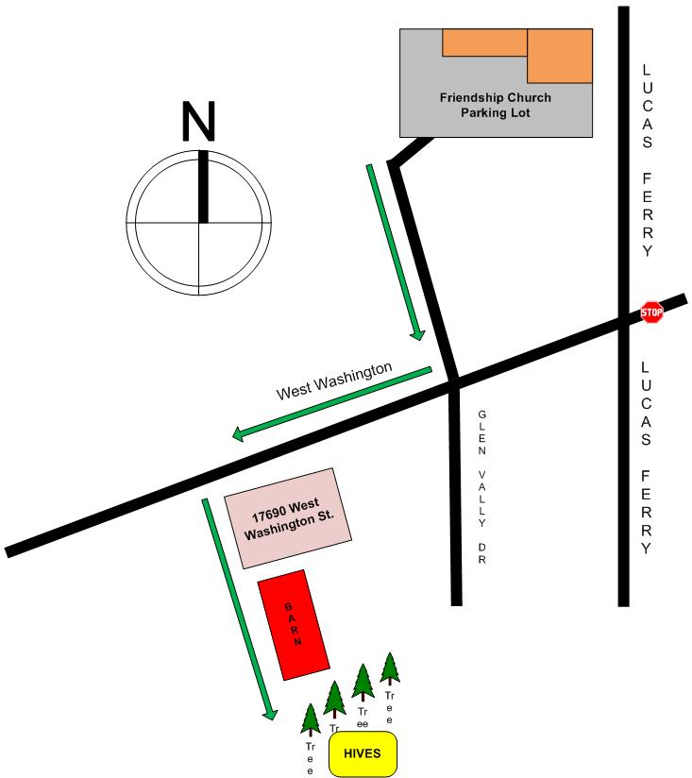
Friendship United Methodist  Classroom Locations and Emergency Exits | 